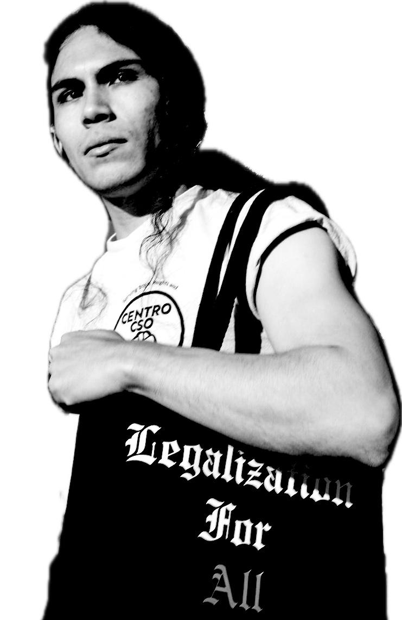**Alejandro Orellana Letter of Support**

Name: ________________________

Address: ______________________

_____________________________

Phone: _______________________

July 25, 2025

United States Attorney's Office

Central District of California

312 N. Spring St. Suite 1200

Los Angeles, CA 90012

Dear Attorney General Essayli,

I write this letter of solidarity and support to stand with Centro CSO member Alejandro Orellana. I demand Federal Prosecutor Bill Essayli drop the political conspiracy charges of conspiracy to commit civil disorder and aiding and abetting on Alejandro, now! Alejandro has done nothing wrong. He is a former Marine, a union member, shop steward, and an organizer for el pueblo de East LA and Boyle Heights.

The charges against Alejandro are bogus. He is being used as an example to scare others into not mobilizing against ICE raids. The videos from news outlets, protesters, and legal observers show the improper use of force (despite the Trump sycophants like Pam Bondi and Emily Covington asserting that their officers are not breaking the law and that their prisons and camps are not violating basic human rights).

This is why I am joining in the collective call — **DROP THE CHARGES ON ALEJANDRO ORELLANA, NOW**. FBI hands off other Centro CSO members like Verita Topete, and ICE out of LA.

Sincerely,